UDP Probing

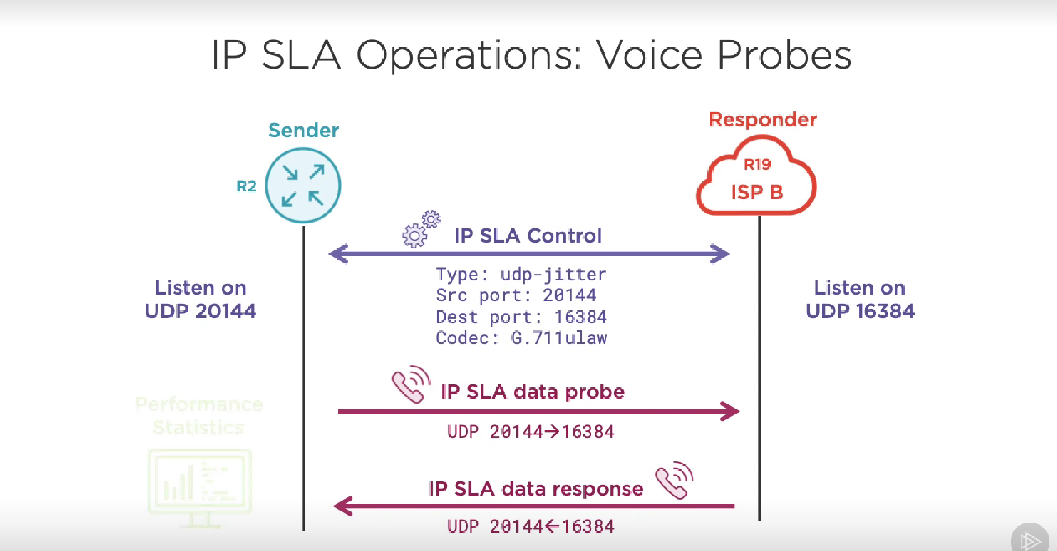

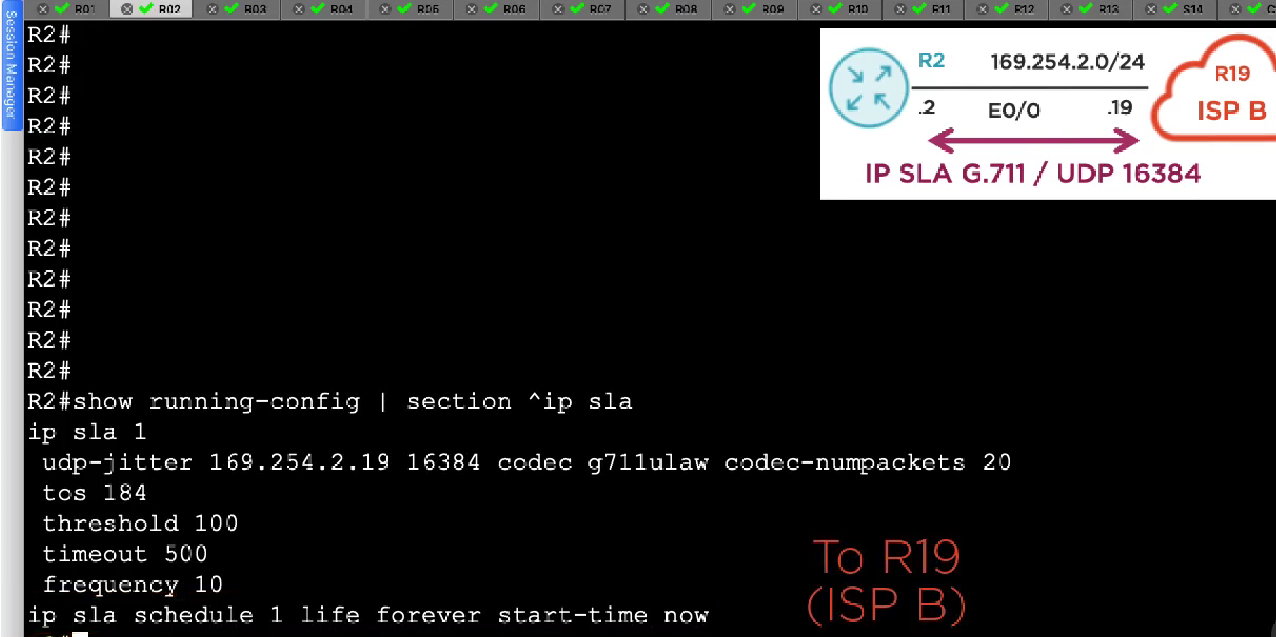

For non icmp ipsla probe you need to configure ipsla on the destination/target device as well.

Just use ip sla responder on destination/target.

Sh ip sla stastics 1

Sh ip sla transponder